**CP Club 365Days Challenge**

**Date – 20/11/2022**

**Programming language – only C++ language**

**Problem Statement**

**Code must be in C++ language only**

[https://practice.geeksforgeeks.org/problems/maximum-occuring-character-1587115620/1?page=2&category[]=Strings&sortBy=submissions](https://practice.geeksforgeeks.org/problems/maximum-occuring-character-1587115620/1?page=2&category%5b%5d=Strings&sortBy=submissions)

**Your Code**:

// 0x34Day of 0x365Days challenge

// VEDANT BHARAD

// 20-11-2022

//{ Driver Code Starts

#include<bits/stdc++.h>

using namespace std;

// } Driver Code Ends

class Solution

{

    public:

    //Function to find the maximum occurring character in a string.

    int howMany(string str,char tofind){

        int count=0,l=str.length();

        for(int loop=0;loop<l;loop++){

            if(str[loop]==tofind){

                count++;

            }

        }

        return count;

    }

    char getMaxOccuringChar(string str){

        int l=str.length(),max=0;

        char maxOccuring;

        for(int loop=0;loop<l;loop++){

            int temp=howMany(str,str[loop]);

            if(max<temp){

                max=temp;

                maxOccuring=str[loop];

            }

            else if(max==temp){

                if(maxOccuring>str[loop]){

                    max=temp;

                    maxOccuring=str[loop];

                }

            }

        }

        return maxOccuring;

    }

};

//{ Driver Code Starts.

int main()

{

    int t;

    cin >> t;

    while(t--){

        string str;

        cin >> str;

        Solution obj;

        cout<< obj.getMaxOccuringChar(str)<<endl;

    }

}

// } Driver Code Ends

**Output (Screen Shot)**:

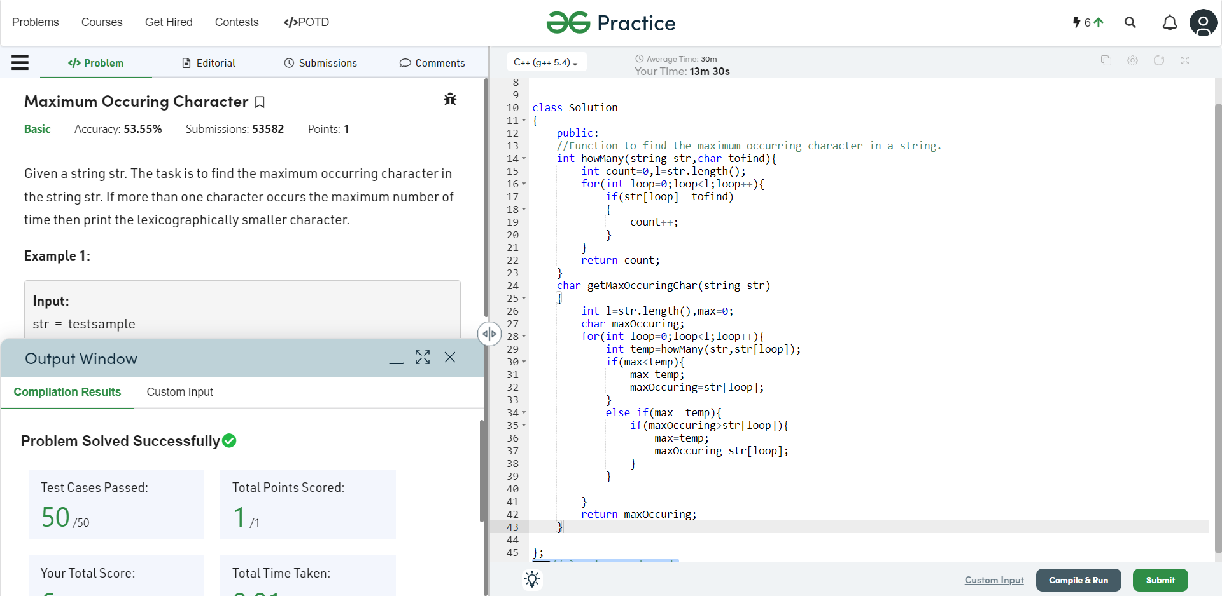

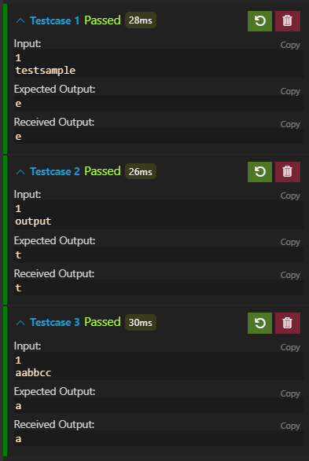

**Understanding about problem:**

1. In this task there is one input string.
2. In this task I need to return character which having the highest frequency.

Note: If you can't understand the problem, feel free to contact us and we'll help you. Please don't copy and paste from anywhere.

ALL THE BEST

Team CP Club